2026 AWȂSIS INDIGENOUS EDUCATION CONFERENCE
April 22nd Early Registration
Register Early on April 22nd from 4 pm to 8 pm to get into draws
Conference on April 23rd and 24th, 2026 Saskatoon Inn, Saskatoon, Saskatchewan
*** sessions subject to change
Conference info: www.awasis.com
FB page: Awasis Interagency Education Conference
Mail: 110 Cockburn Crescent; Saskatoon, SK S7L 5R9
Debbie: 306-290-6068 (Exhibitor tables/Conference Information) Sandra Frantz 306-220-0695 (Registration)

e-mail us at: awasisconf@gmail.com

Theme: A Path Forward to Indigenous Education
Registration Package on line www.awasis.com

In person early registration: Wednesday, April 22nd at 4 pm – 8 pm;
Thursday, April 23rd at 8 am – 4 pm; Friday, April 24th at 8 am – 11:30 am
Champagne Area in the Saskatoon Inn
Free Breakfast from 7:30 am – 8:30 am (Ballroom A&B&C)
(For all PAID delegates)
Thursday Welcome & Greetings: 8:30 am

Thursday KEYNOTE SPEAKER
8:45 am - 10:00 am
John Langan

Free Breakfast from 7:30 am – 8:30 am (Ballroom A&B&C)
(For all PAID delegates)
Friday Welcome & Greetings: 8:30 am

Friday KEYNOTE SPEAKER
8:45 am - 10:00 am
Rosella Tsannie-Burseth

2026 Registration price is as follows:
$450/person OR $400/Elder
***PAYMENT BY CHEQUE/CASH ONLY (NO CREDIT CARDS)***

Buffet Breakfast and lunch are free for PAID delegates/exhibitors only. (one person from exhibitor table) Extra lunch tickets can be purchased for $50.

Schedule at a Glance

April 23
Thurs 7:00 am – 8:00 am Pipe Ceremony (Alberta Room Max. 15 people)
7:30 am – 8:30 am Buffet Breakfast in Ballrooms A, B, C
8:30 am – 8:45 am Welcome and Greetings
8:45 am - 10:00 am Keynote in Ballrooms A, B, C
10:00 am -10:15 am Break
10:15 am – 11:30 am Breakout Sessions
11:45 am – 12:45 pm Lunch in Ballrooms A, B, C
1:00 pm - 3:45 pm Breakout Sessions
April 24
Fri. 7:00 am – 8:00 am Pipe Ceremony (Alberta Room Max. 15 people)
7:30 am – 8:30 am Buffet Breakfast in Ballrooms A, B, C
8:30 am – 8:45 am Welcome and Greetings
8:45 am - 10:00 am Keynote in Ballrooms A, B, C
10:00 am -10:15 am Break
10:15 am – 11:30 am Breakout Sessions
11:45 am – 12:45 pm Lunch in Ballrooms A, B, C
1:00 pm - 2:15 pm Breakout Sessions

* We will post any changes to sessions on the website and at the registration table.

Thursday, April 23rd
7:00 am – 8:00 am Pipe Ceremony – Alberta Room (Max. 15 people)
7:30 am – 8:30 am Breakfast in Ballrooms A, B & C
8:30 am - 8:45 am Greetings Ballroom A, B & C
8:45 am -10:00 am Keynote Ballroom A, B & C

Keynote: John Langan

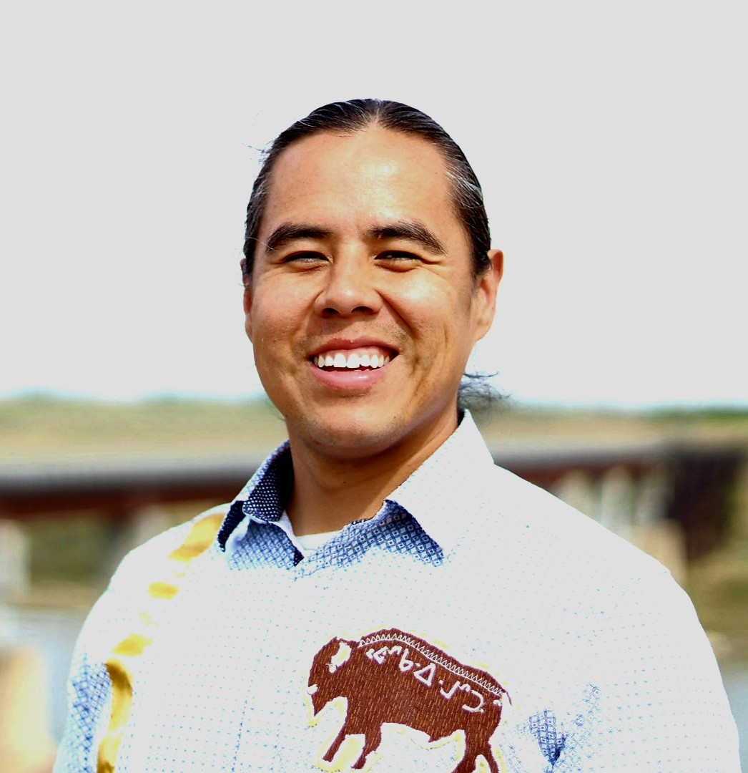
Biography:

John is a proud member of Keeseekoose First Nation. He is an award-winning author and speaks professionally to thousands of people nationwide on a story of resilience, intergenerational residential school trauma, and the ability to overcome obstacles in life through perseverance and determination. He is a soldier, police officer, traditional knowledge/language keeper, and most importantly a husband and father. John is driven to share the beauty of indigenous culture and ceremony. His story will motivate and build resilient leaders and organizations.

John’s work focuses on themes of resilience, identity, and the power of storytelling. Through his website, www.asparkinthedark.com, and his speaking engagements, he shares his journey to empower young people in identifying their gift given to them by the Creator.

John will be available after his breakout session to sell and sign his books in the Champagne area which is near the registration table.

#100 series Thursday – 75 Minute (10:15 – 11:30)

#100 Smudge Ceremony
Jamin Mike Alberta Room (limited to 15 Participants)

Smudging is a spiritual way to cleanse a person, place or an object of negative energies, spirits, or influences. The smudging ceremony involves the burning of special, sacred plants and fanning the smoke around a person, place, or an object. Participants will participate in a smudge ceremony and discuss the protocol of ceremonies.

#101 Follow up to the Key Note
John Langhan Ballroom A (limited to 150 participants)

My session will be explaining the lesson plans (created by teachers for teachers) and I will address other workshops I offer in-house and in-school. I will address anti-bullying, anti-suicide, anti-gang, discovering self-worth and resilience.

My lesson plans for Grade 9-12 will be available for sale in the Champagnes area which is near the registration table.

#102 Storytelling Through Phonics Instruction
Cassie Raye Ballroom B (limited to 175 participants)
Co-Presenter Patricia Johnson

Storytelling Through Phonics Instruction integrates a culturally responsive approach to teaching phonics and early literacy by incorporating traditional First Nations storytelling practices. Historically, First Nations peoples across Canada and the United States have used creation stories and oral storytelling as foundational methods for passing down knowledge. By continuing this rich tradition in the classroom, First Nations children can develop essential foundational literacy skills while honoring their cultural heritage—equipping them to thrive as 21st-century learners. Grounded in the Science of Reading. This session equips participants with practical strategies to support foundational literacy development, particularly phonics instruction, for First Nations students.

#103 Artificial Intelligence – Helping Teachers Teach
Bill Fahlam Ballroom C (limited to 150 participants)
Co-presenter Curtis Clements

Artificial Intelligence is a transformative tool that can revolutionize teacher practice. In this session, we will explore the many ways in which AI can enhance teaching, improve student learning, and streamline administrative tasks.

#104 Title of Session: Mitho-pimatsiwin Our way of life
Lorissa Beatty Ballroom B (limited to 150 participants)

The Woodland Cree culture and the six seasons we respect. Along with all the significant teachings that need to be passed down to the younger generations for the crucial skills to survive the North. Teachings from local Elders and Knowledge Keepers of the Montreal Lake Cree Nation.

#105 20 Years of Indigenization at Muskoday School
Dustin Brass Courtyard (limited to 100 participants)

Improvisational-Education-Making
Through this presentation we will begin to answer and define what improvisational-education-making is to us in our many contexts, and how its design for youth develops engaged experiential processes that encourage meaning-lead learning. Foundational stories applied to Narrative Inquiry dimensions of unpacking assist in the exploration and actualizing of a tangible place forward for all levels of individuals in the education field. This two-session presentation engages both present and conference participants to create avenues to implement this into their education spaces.

#106 Beaded Christmas Ball
Grace Mosquito Brass Lantern (limited to 25 participants)

Come learn how to make a beautiful Christmas Ball ornament. Create your own unique beaded Christmas Ball. Beginner beaders are welcomed.

All supplies are provided

#107 Handheld Moss Bag
Kristy Javier Manitoba Room (limited to 60 participants)

Holding our ancestors wrapped in the future. A moss bag is a traditional way to wrap babies. Rocks have been my subject matter for project “Weight we Carry” Creating these small handheld moss bags as we converse, learn and share in the making process.

All supplies provided.

#200 series Thursday–Half Day (1:00-3:45)

#200 Reclaiming Ogitchidaa Teachings: Healing Lateral and Vertical Violence Through a Trauma-Informed Lens
Rachel Fiddler Ballroom A (limited to 150 participants)

Lateral violence is a symptom of colonization that has evolved into harmful vertical power dynamics across workplaces, families, and communities. This workshop, developed and facilitated by Charisse, Danna, and Rachel – MSW students at the University of Toronto and members of Saskatchewan First Nations – draws on traditional teachings and local knowledge to support healing and empowerment. Participants will explore the ogitchidaa/okihcihtâ (warrior) spirit, reconnect with the strength of lateral kindness, and gain practical tools to address lateral and vertical violence. The session offers a trauma-informed, culturally grounded space to reflect, heal and build personal collective resilience.

#201 Nurturing Emotional Intelligence in Students: Implementing Self-Regulation Tools in the Classroom
Candace Fox Ballroom C (limited to 150 participants)

In today’s educational landscape, the classroom has evolved beyond a space for predictable subjects like science, math, and history. Educators recognize that fostering students’ emotional intelligence (EQ) is just as crucial as developing their intellectual abilities (IQ)

Self-regulation is a fundamental pillar of emotional intelligence, alongside self-awareness, motivation, empathy, and social skills. When students lack self-regulation, their emotional intelligence is significantly affected, along with their learning and cognitive abilities.

In this workshop, we will discover how self-regulation underpins the essential components of emotional intelligence: self-awareness, motivation, empathy, and social skills. We will explore three self-regulation tools that can be implemented in the classroom to support both student well-being and, of course, academic success. We aren’t just expanding young minds; we are also nurturing young hearts.

By understanding this interconnectedness and equipping educators with tools they can use in the moment, the classroom becomes a supportive environment that enhances both emotional and academic growth for students.

#202 Medicines and Sage Salve Making
Sharon Meyers Canadian Room (limited to 40 participants)
Medicine is part of the Medicine Wheel Teachings. Come, listen and learn about how Medicine surrounds us. The root people, the Medicine people, are our relatives and have a purpose to take care of the humans. Let’s visit the medicine world and reconnect our relationship to the plant world. We will have the opportunity to learn to create salve with sage medicine. This workshop filled to capacity last conference so don’t be late. Doors will be open to maximum 40 participants.

203 Make and Take Birch Bark Biting
Rosella Carney Manitoba Room (limited to 40 participants)

Birchbark biting is an Indigenous artform in which the artist bites on small pieces of folded birch bark to form unique designs. This workshop will give you the opportunity to learn about shapes and their properties as you discover how to bite different shapes into the bark.

#300 series Thursday – (1:00 pm - 2:15 pm)

#300 Treaty Education
Elaine Sutherland Ballroom B (limited to 175 participants)

Teaching treaties in the classroom is mandated to be taught in all provincial Schools. The Office of Treaty Commissioner has aligned the K-12 “Treaty Education Outcomes and Indicators” with the K-12 Treaty binders, OTC has also developed teacher guides for Treaties 4, 6, 6A and Treaties 1-11. Come and learn how to use these new resources to teach Treaties in your classroom. You will Also learn practical applications to teach about First Nation People and Treaties. Delegates will have the opportunity to discuss successful practices and will also receive digital resources.

#301 Wîcihitowin maskihkîy (helping each other through medicine)
Cortney Bear Courtyard Room (limited to 100 participants)

I Share how I came to learn medicines. Teach on the protocols to picking medicines and steps of how to store the medicines. Share on some of the medicines and properties they do for the body.

#302 Empowering Indigenous Communities Through Culturally Rooted Traffic Safety Education
Juliany Qureshi Brass Room (limited to 30 participants)

SGI is dedicated to supporting the safety and well-being of Indigenous children by providing accessible, culturally respectful traffic safety education. This presentation will introduce our free Kindergarten to Grade 3 Traffic Safety resources—designed to help educators, families, and community members teach essential school bus, passenger, bike, and pedestrian safety in ways that honor Indigenous knowledge and community strengths.
Grounded in the belief that safety education is a shared responsibility, this session highlights how traffic safety can become an empowering tool for Indigenous communities. Participants will explore approaches that celebrate cultural identity, respect traditional teachings, and strengthen community-led learning.
This presentation will:
- Center Indigenous Voices and Storytelling: Share a safety-themed Indigenous story that blends cultural teachings with modern-day road safety, demonstrating how traditional knowledge can guide children in making safe choices.
- Support Community Leadership in Safety Education: Provide practical, adaptable strategies that educators, parents, Elders, and community leaders can seamlessly integrate into daily routines and land-based learning.
- Showcase SGI’s Free Educational Resources: Highlight interactive materials designed to empower Indigenous communities with engaging, age-appropriate safety tools.
- Create Space for Collaborative Dialogue: Invite participants to share community needs, experiences, and ideas on strengthening safety education through culturally grounded approaches.
Why this matters:
The Awasis Indigenous Education Conference empowers educators and community leaders to uplift Indigenous youth through culturally connected learning. This session reflects that mission by offering tools and strategies that not only enhance safety awareness, but also reinforce cultural pride, community collaboration, and collective responsibility for children’s well-being.
Participants will leave with:
- Ready-to-use safety education materials that support both classroom and community programming
- Culturally meaningful approaches that place Indigenous identity and teachings at the center of learning
- Opportunities to work alongside SGI on future initiatives that elevate Indigenous leadership in child safety
SGI is honored to support Indigenous empowerment by sharing knowledge, resources, and collaborative pathways that help keep children safe while celebrating the strength and resilience of Indigenous communities.

#400 series Thursday – (2:30 - 3:45)
#400
Dustin Brass Ballroom B (limited to 175 participants)

Improvisational-Education-Making
Through this presentation we will begin to answer and define what improvisational-education-making is to us in our many contexts, and how its design for youth develops engaged experiential processes that encourage meaning-lead learning. Foundational stories applied to Narrative Inquiry dimensions of unpacking assist in the exploration and actualizing of a tangible place forward for all levels of individuals in the education field. This two-session presentation engages both present and conference participants to create avenue to implement this into their education spaces.

#401 Representing Metis children in the early years
Leah Dorion Courtyard Room (limited to 100 participants)

Metis artist Leah Dorion will share about how to use her newest Board books in your class which feature young metis children learning about their world.

#402 Beaded Christmas Ball
Grace Mosquito Brass Lantern (limited to 25 participants)

Come learn how to make a beautiful Christmas Ball ornament. Create your own unique beaded Christmas Ball. Beginner beaders are welcomed.

All supplies are provided

Friday, April 24th
7:30 am – 8:30 am Breakfast in Ballrooms A, B & C
8:30 am - 8:45 am Greetings Ballroom A, B & C
8:45 am -10:00 am Keynote Ballroom A, B & C

Keynote: Rosalie Tsannie-Burseth

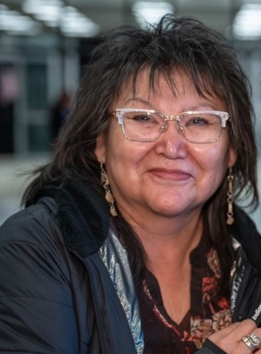

Description:
Rosalie Tsannie-Burseth, is a member of Hatchet Lake Dënesųlinë First Nation, she dedicates her lifelong career in the K5-12 and post-secondary education. She taught in the classroom and served in administration for the Hatchet Lake Education Program from 1987-2007 and Associate Director of Education at Prince Albert Grand Council Education from 2009-2020. Rosalie was Chief of Hatchet Lake Band from 2007-2009. She earned a Bachelor of Education (1990) and a master’s degree in Curriculum and Instruction (2001) and is currently a Ph.D. candidate at the University of Saskatchewan, focusing on Dënesųlinë history, language, and culture.
Her deep commitment to fostering educational opportunities has not only shaped her own academic path but has also positively influenced countless students and colleagues throughout her career. In addition to her professional achievements, Rosalie’s ongoing research and studies in Dënesųlinë history, language, and culture reflect her dedication to preserving and sharing the rich traditions of her community. Her leadership and passion for lifelong learning continue to inspire those around her as she remains actively engaged in local, regional and national academic circles.

#500 Series Friday – 75 minutes (10:15-11:30 am)

#500 Follow up to the keynote
Rosalie Tsannie-Burseth Ballroom A (limited to 150 participants)

The Land Speaks Metaphorically
Language empowers and preserves culture. Land plays a key role in linguistic practices, as stories often relate to spiritual sites and historical events. Traditional storytelling includes genres linked to people and place names. Sharing narratives transmit knowledge and deepens our understanding of relationships with the land (nih – land).

#501 Storytelling Through Phonics Instruction
Cassie Raye Ballroom B (limited to 175 participants)
Co-Presenter Patricia Johnson

Storytelling Through Phonics Instruction integrates a culturally responsive approach to teaching phonics and early literacy by incorporating traditional First Nations storytelling practices. Historically, First Nations peoples across Canada and the United States have used creation stories and oral storytelling as foundational methods for passing down knowledge. By continuing this rich tradition in the classroom, First Nations children can develop essential foundational literacy skills while honoring their cultural heritage—equipping them to thrive as 21st-century learners. Grounded in the Science of Reading. This session equips participants with practical strategies to support foundational literacy development, particularly phonics instruction, for First Nations students.

#502 Artificial Intelligence – Helping Teachers Teach
Bill Fahlam Ballroom C (limited to 150 participants)
Co-presenter Curtis Clements

Artificial Intelligence is a transformative tool that can revolutionize teacher practice. In this session, we will explore the many ways in which AI can enhance teaching, improve student learning, and streamline administrative tasks.

#503 Handheld Moss Bag
Kristy Javier Courtyard Room (limited to 50 participants)

Holding our ancestors wrapped in the future. A moss bag is a traditional way to wrap babies. Rocks have been my subject matter for project “Weight we Carry” Creating these small handheld moss bags as we converse, learn and share in the making process.

All supplies provided.

#504 Make and Take – Moose/Caribou Hair Tufting Art
Rosella Carney Brass Lantern Room (limited to 25 Participants)

Tufting involves the twisting of moose or caribou hair into three-dimensional image. It is an old Athapaskan art. Come learn this art technique and produce your own unique piece of art.

#505 Beading with Safety Pins
Sharon Meyer Manitoba Room (Limited to 50 participants)

Beading is not about art when it comes to the curriculum – it is math! Come learn about patterns and using safety pins instead of needle and thread. This is a hands on activity and you will walk away with a beaded pattern on a safety pin base. Come and learn a basic form of beading that will bring success to all participants. Activity is suitable for students grades 4 to adults.

#506 Problem Solving using JUMP Math – Gr 3-7
Elizabeth Barrett Alberta Room (Limited to 25 participants)
Novice mathematicians can’t be treated like experts. If we do they lean in a highly inefficient way, and we kill their confidence and desire to solve the problem. Instead, by tackling well-designed problems that develop incrementally and don’t vary too much from problem to problem, students can be successful, feel more confident, and enjoy the problem-solving process.
JUMP Math helps teachers to implement lessons through our systematic approach to teaching c
which fosters both confidence and deep understanding in mathematics. By combining clear, structured teaching with moments of inquiry, JUMP Math provides a model for transforming your math teaching.

#600 series Friday – 75 minutes (1:00 pm – 2:15 pm)

#600 Treaty Education
Elaine Sutherland Ballroom A (limited to 150 participants)

Teaching treaties in the classroom is mandated to be taught in all provincial Schools. The Office of Treaty Commissioner has aligned the K-12 “Treaty Education Outcomes and Indicators” with the K-12 Treaty binders, OTC has also developed teacher guides for Treaties 4, 6, 6A and Treaties 1-11. Come and learn how to use these new resources to teach Treaties in your classroom. You will Also learn practical applications to teach about First Nation People and Treaties. Delegates will have the opportunity to discuss successful practices and will also receive digital resources.

#601 Title of Session: Mitho-pimatsiwin Our way of life
Lorissa Beatty Ballroom B (limited to 175 participants)

The Woodland Cree culture and the six seasons we respect. Along with all the significant teachings that need to be passed down to the younger generations for the crucial skills to survive the North. Teachings from local Elders and Knowledge Keepers of the Montreal Lake Cree Nation.

#602 Storytelling Through Phonics Instruction
Cassie Raye Ballroom C (limited to 150 participants)
Co-Presenter Patricia Johnson

Storytelling Through Phonics Instruction integrates a culturally responsive approach to teaching phonics and early literacy by incorporating traditional First Nations storytelling practices. Historically, First Nations peoples across Canada and the United States have used creation stories and oral storytelling as foundational methods for passing down knowledge. By continuing this rich tradition in the classroom, First Nations children can develop essential foundational literacy skills while honoring their cultural heritage—equipping them to thrive as 21st-century learners. Grounded in the Science of Reading. This session equips participants with practical strategies to support foundational literacy development, particularly phonics instruction, for First Nations students.

#603 Wîcihitowin maskihkîy (helping each other through medicine)
Cortney Bear Courtyard Room (limited to 100 participants)

I Share how I came to learn medicines. Teach on the protocols to picking medicines and steps of how to store the medicines. Share on some of the medicines and properties they do for the body.

#604 Math is Childs Play with JUMP Math
Elizabeth Barrett Brass Lantern (limited to 40 participants)

Early numeracy is a key to academic success and exploring games that carefully develop counting and spatial understanding, is an essential part of Pre-K and Kindergarten, Gr 1 and 2 learning. In this workshop we will explore the ne PRIMA JUMP Math series 3-5 year olds. Developmentally sequenced activities and games for teaching counting, subitizing, pattern recognition, spatial reasoning, and more!

Help children realize, through hands on experience and games, that everyone can succeed in math.

#605 FINDING YOUR DIRECTION
Kristy Janvier Manitoba Room (limited to 100 Participants)

Using the Medicine Wheel teachings and Wheel of Life (Rebecca Hass), we’ll look at where we sit with different aspects of our life and where we want to direct our energy and focus in this season of life.

#607 Tipi Teachings
Elder Mary Lee Alberta Room (limited to 25 Participants)

I will teach about the Plains Cree tipi teachings as they were shared with me from my mother and grandmother. The tipi teachings guide our life and bring balance to our home and family as well as to our classrooms and communities. You will learn the making of a teepee as well as the roles and responsibilities for having a teepee in your school or centre.

Buffet Breakfast and lunch are free for PAID delegates/Exhibitor (one vendor per table)
Extra lunch tickets can be purchased for $50.

